Sl | Item Description | UoM | Qty. | Unit Price in BDT (Including All Charges, VAT, Tax, etc.) | Total Price in BDT (Including All Charges, VAT, Tax, etc.)
1 | Martial Art Dress with Belt as per specification given under "Deliverable Table" | Set | 80
3 | Martial Art Training  Class Duration : 2 Hours per day  Number of Location : 4 Location  Number of Participants : 20 person in each group (20 Person x 4 Location = 80 Person)  Total number of class : 9 Class per month x 8 Month x 4 Location = 288 Class | Class | 288
Grand Total =
Amount in words :
Attachment 3: Financial Proposal Submission Template

Please Check the Box (Yes/No, if yes kindly provide proper evidence that will be treated as evaluation purpose):

Sl. | Question | Yes / No (if yes kindly provide  proper evidence)
1 | Do your institute have update Trade License
2 | Do you have Female Trainer age not less than 18 Years to maximum 45 Years
3 | Do you have sufficient number of Female Trainers
4 | Do your Female Trainers are Black Belt awardee in the area  of Chinese Marshal Art/Wushu
5 | Do your Female Trainers are Certified on this area of  Marshal Art
6 | Do your Female Trainers are Awardee in  National/International level in this area of Marshal Art/Wushu
7 | Provide a list (as a separate attachment) of all of the  customers for relevant solutions/service (WVB may ask the referrers/customers about your service quality)

Name & Signature of the Vendor/Service Provider:

Name of the Company/Organization:

Date with Seal/Stamp of the Company/ Organization:

Delivery time/schedule: As per attached ToR - 3

Attachment 3: Terms of Reference (TOR – 3)

Tongi, Gazipur
Terms of Reference (ToR)
of
Martial Arts training for self-defense to girls to protect themselves to end all forms of violence against them.

About World Vision
World Vision is one of the world's largest international NGO, a Christian humanitarian development and advocacy organizations, committed to helping children and families in poor communities to improve their lives and alleviate poverty.

World Vision has been active in Bangladesh since 1970. Bangladesh being one of the largest country offices of World Vision. Prior to Bangladesh's independence in 1971- World Vision Bangladesh's efforts mainly focused on disaster relief following a cyclone in the coastal region of Bangladesh. In 1972, World Vision opened its office in Bangladesh. That same year, a childcare program provided direct assistance to children aged 4-14. Since then, World Vision has been working with the Government, civil society, the media, corporate sector and other national and international partners to ensure that all Bangladeshi children go to school, access health care and are protected from violence, neglect, abuse and exploitation. World Vision is playing a critical role and is applying global best practices to strengthen health, education and child protection systems and services, and to empower families with knowledge to better care for their children.

In Bangladesh, World Vision operates for unprivileged children and adult through implementing 15 Area Program Clusters, 56 Area Program and 12 grant-funded projects in 27 districts and is benefitting well over 5,00,000 children and their families.

About Martial Art
This martial art comprises of sharp, precise and linear actions and movements. Its traditional themes work on the disciplines of dedicated training, fighting and self-defense techniques.

Karate is a well known form of Martial Arts, which is highly effective for self defense exercises, defensive attack and counter attacking body movements. Although this teaches an individual the art of attacking and self-defense, the sole motive is the self-improvement. Discipline, persistent effect, mind balance are some key words that defines best a Karate practiser. The word “Kara” means Empty and “Te” means Hand. A suffix “Do” (Karate-do) adds meaning of defending himself empty handed.

The practitioner will learn to focus their power in punches and kicks which are designed to be of very high impact. In the other forms or styles, grappling, throwing, joint-locking, restraints, and vital point strikes are also used and applied.

Winning a battle is not the only aim in karate. It is the best efficient way of using the human body to learn self-defense through blocking, punching, blowing and kicking techniques. It balances both the body and mind as well. It also teaches an individual to possess gratitude of restraining himself from any violent attack before the start of any actual fight. Today, the art form is privileged and practiced all over the world.

Belt Colours and Meaning
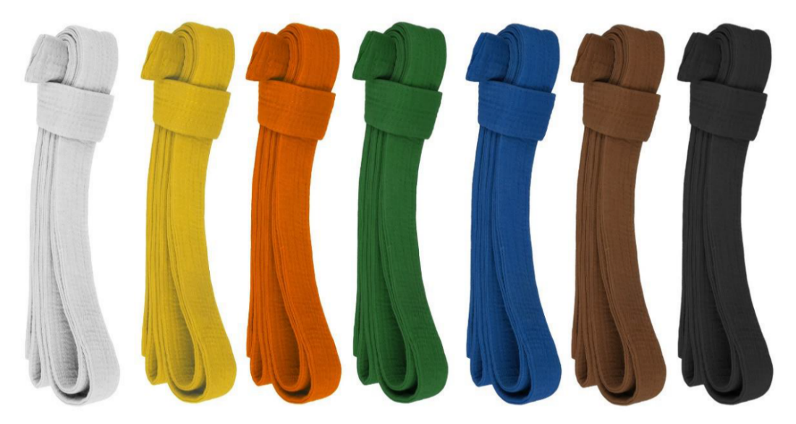

White Belt - The birth of a new light is indicated by white. In karate it usually depicts for a person who starts to learn karate keeping in mind about the different challenges that he is going to face.
Yellow Belt - It symbolizes the first ray of sun light. In karate its meaning is that now the student’s mind is open to accept more possible techniques and methods.

Orange Belt - This light is an indication of spreading of light on the earth. So it shows how the student is expanding its knowledge in the field.

Green Belt - It depicts the penetration of steams and roots of the plant to get the sun light. In turn this means the student is developing new skills and learning new techniques to master the game.

Blue Belt - The plant is growing up towards the sky which is blue in color. That means student is going deeper to understand each move in karate and differentiating each to gain more knowledge.
Purple Belt - It indicates that the student is very serious about acquiring new belts that is coming across next.

Brown Belt - This shows that the plant is full grown and it is ready for the harvesting. Similarly in karate it indicates that the student has gained adequate knowledge about the skills and now he is ready for the combat.

Red Belt - It signifies the depth of the knowledge that a student possesses and ability to give those a successful direction.

Black Belt - Every glowing object has a dark shadow behind it and that is what this color is all about. This belt shows that the person wearing it has mastered all the skills and he poses a great ability within him to enlighten others with his knowledge.

Purpose of the training | - Enhanced agency of girls to protect them from violence.  - Positive engagement of boys to protect girls from gender based violence.  - Improved formal and informal system at all level to protect girls from gender based violence.  - It will help Girls to build confidence.
Identified areas/topics for this training | As per section “Specific tasks of the training provider”
Duration | 8 - 9 Month (January 2023 to September 2023)
Reporting to | Lawrence Falia, PO-CESP, Tongi UP, World Vision Bangladesh.

Overall objective of the project
The overall objective of the project is to “help Girls to build confidence”.

General Terms and Conditions
- Responsibility of the organization conducting the training
- Training duration and timeframe will be as per section “Timeframe of the training”. However, the duration of the training may extended or reduced with the consent of both parties.
- Four centers for girls’ child empowerment, physical fitness enhancement and under the safety scheme, training will be conduct in accordance with the policy at the designated / defined places of the World Vision Working area as per section “Training Location”.
- The Trainer must be a woman and age should be in between 18 to 45 years old.
- Instructor / Trainer must have below expertise and certifications
- Trainer or the organization must share the updated CV (not more than 2 page) of the Trainer
- Well experienced and professional in training of Martial Art (Shotokan Karate)
- Have Black Belt Certificate from reputed academy of National / International level
- Any other Certificate of any National / International level competition
- The trainer and his/her assistant must sign supplier code of conduct
- The trainer have to sign and abide by the security policy of World Vision Bangladesh.
- The training should be scheduled according to the convenience time of the trainees (Considering the school time) and the trainer must conduct training in each center at least 2 hours per day.
- The trainer have to conduct the training at the place and time determined by World Vison Bangladesh.
- The trainees will have to provide an institutional certificate at the end of the course.
- After issuing the work order, the report of the work done as per the plan has to submitted along with bill by the date of 25th of each month.
- The bill has to be submit according to the class performed monthly according to the calculation of the work done.
- Will implement the advice and feedback given by World Vision Bangladesh officials.

- Responsibility of World Vision Bangladesh
- World Vision Bangladesh will ensure four centers for girls’ child empowerment, physical fitness enhancement and under the safety scheme, training will be conduct in accordance with the policy at the designated / defined places of the World Vision Working area as per section “Training Location”.
- A list of 20-30 girls should prepare for each center and should confirm the place of training and the letter of consent from the trainee and the guardian.
- World Vision Bangladesh will not provide any kind of travel, entertainment or any other expenses of the trainer and or the assistant.
- World Vision Bangladesh will arrange monthly / quarterly meetings with trainees, trainers and officials of training institutes if required.
- Each month World Vision Bangladesh will collect progress reports and other information on the training conducted.
- World Vision Bangladesh will pay the bill according to the class and by head of trainees performed monthly.
- During the training, World Vision Bangladesh staff will provide training supervision and necessary advice for the proper implementation of the activities.

Specific tasks of the training provider
Under the direct supervision of the World Vision Bangladesh, the training provider will be required to train and certify at end of the training as stated below:

Basic Punch : The most common form of punching because this does not need much movement of your body part to generate power. It is just made to release the tension and to make a proper connection. It involves just punching in the air slowly with both your hands periodically but a bit slowly. Initially keep the face of your grip towards up but as you gradually move towards punching, at the last moment turn your wrist along with elbow such that the face of the grip will now face downward. Repeat the same with the other hand too.
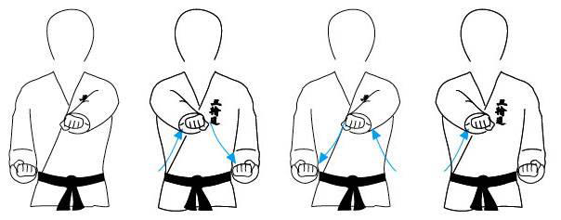

Blocking : Blocking teaches us how to do a fore arm block. From your normal position either step in or step back. Raise your blocked arm. It should shoot out towards the attacker. Then move the arm to the back and towards the reverse direction of the body. In this very moment connect your attacking arm with your fore arm. Pull the arm back and repeat the same thing again with another hand.

Upper Rising block : In upper rising block you have to maintain your body posture as shown in the figure below. One hand should be above your head and another just by the side of your waist. Then you have to switch your position just opposite with a lightning fast speed. The aim is to block any sudden thrust towards you from your opponent.
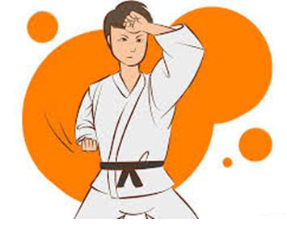

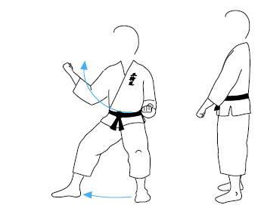
Middle Block : The initial body posture will be just like keeping your own arm straight vertically upward with the ground and another at your waist level facing forward. In the next step you have to move your horizontal hand towards vertical one with a 135 degree angle, with lightning speed. Repeat the same with other hand too.

Front Kick : Mae Geri teaches you to attack a person with the balls of your foot. Strengths can be centralised at the balls of the foot while raising it up in the air and can be focused upon the joint parts of your opponent with a quick kinematic force, resulting in high impulsive strike.
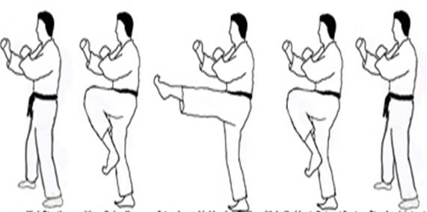

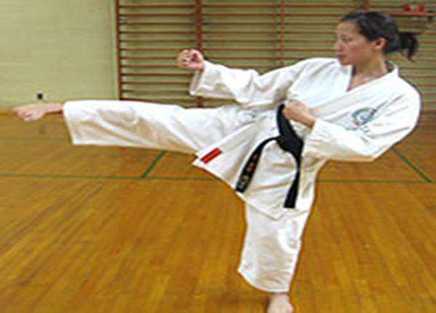
Side Kick : Here we use the side or blade of our foot. The attack is done side wise upon the lower part of the opponent. The wider you take back the foot in air gathering potential energy, the stronger will be the impulse due to high kinetic energy.

Round House Kick : In this we have to hit the opponent with the ball of our foot like Mae geri but the process is slightly different. We have to curl our toes up and after that we should make the movement of our foot sideways.
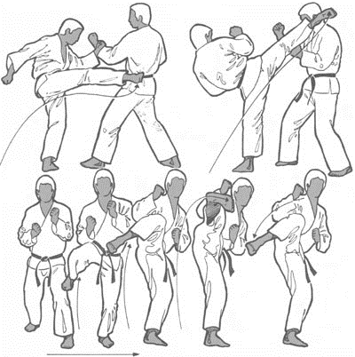

Hook Kick : First step is to keep your foot apart. Keep your right foot forward and left foot backward. Now take the right foot upward. The higher you take the stronger will be the impulse. Now instead of attacking on the left side of the opponent, attack on the right side with your right foot without leaning back.

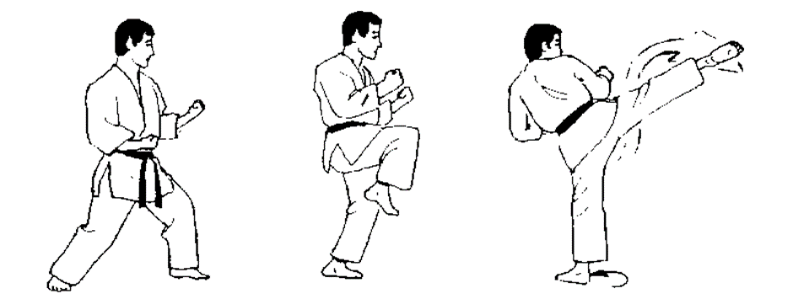

Back Attack : Here one will focus on how to attack his opponent from the backside. The principle of attack remains the same as that of Hook kick. But with a slight difference that instead of attacking from the front end we have to move our leg towards back.
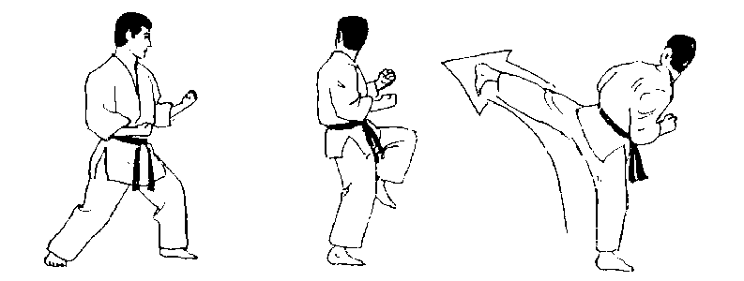

List of Shotokan Kata’s
 | Kata | No. of moves | Kata meaning
√ | Heian Shodan | 21 | “Peacefull Mind One”
√ | Heian Nidan | 26 | “Peacefull Mind Two”
√ | Heian Sandan | 20 | “Peacefull Mind Three”

Belts and Ranks for Shotokan Karate
 | Belt Colour | Rank | Kata required for next belt/grading
√ | White Belt / 9th KYU | 9th KYU | Heian Shodan
√ | Yellow Belt / 8th KYU | 8th KYU | Heian Nidan
√ | Orange Belt / 7th KYU | 7th KYU | Heian Sandan

Training Location
SL | Name of UP | Name of PFA | Training Venue / Location Info
1 | Tongi UP | Himerdigee | Sar Factory, 46 no. Ward, Tongi, Gazipur
2 | Tongi UP | Ershadnagor | TDH School, Block no. 3, Arshad Nogor, Tongi, Gazipur
3 | Tongi UP | Satish | Hasan Chowdhury / Sataish School, Gazipura, Tongi, Gazipur
4 | Tongi UP | Machimpur | Haidar Public School, 53 no. Ward, Tongi, Gazipur

Work Process
The service provider should work closely with project team of Tongi UP, World Vision Bangladesh.

Deliverables
SL | Product / Services Info | Module / Sample
1 | Full set Dress and Belt with WV Logo (as per Sample)  ** 80 set of dress and Belt required  Fabric information (For Dress and Belt)  Composition : 100 % Cotton  Colour : White  GSM : 220 to 260  Stitch : Well stitched  Dress Size  As per measurement of trainee  Belt Size  Thickness : 3 to 4 mm  Width : 2 to 2.25 Inch  Length : Standard  WV Logo  Printing : High Quality Screen Print  Colour : 5 Colour  Size : Width 5 Inch x Height will be proportionate of Width | 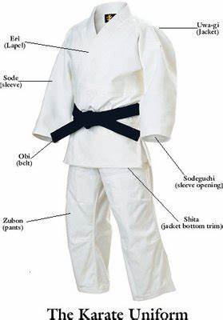
2 | Basic Training and Physical Fitness | All basic physical exercise  All basic forms of Martial Art  All basic method as shown above
3 | Training on White Belt and its evaluation for Yellow Belt
4 | Training on Yellow Belt and its evaluation for Orange Belt
5 | Training on Orange Belt and its evaluation for Green Belt
6 | Certification | 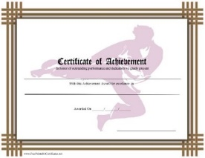

Timeframe of the training
The selected trainer will be working under World Vision contract of services for the designated period defined below

SL | Breakdown | Quantity
1 | Total number of trainee | 80 Person (20 Person in each group / location)
2 | Number of classes per month | 9 (Each class should run 2 hours minimum)  Total : 9 Class x 8 Month x 4 Location = 288 Class
3 | Number of area for training | 4 Location
4 | Number of Trainer | 1 per Location
5 | Number of assistant for Trainer | 1 per Location (if needed / Optional)

Head | Feb-23 | Mar-23 | Apr-23 | May-23 | Jun-23 | Jul-23 | Aug-23 | Sep-23
Basic / White Belt
Evaluation Part-01
Yellow Belt
Evaluation Part-02
Orange Belt
Evaluation Part-03
Certification

Evaluation area (as per below attached documents)

Stage | Evaluation Criteria (as per attached document)
Basic / White to Yellow Belt
Yellow to Orange Belt
Orange to Green Belt
Payment
- WV will disburse payment per class basis on submitted Invoice.
- Payment will sent to suppliers account within 15 days from the date of invoice received.
- Payment will send to supplier account through BEFTN / S2B.

Reservations and Confidentiality
- World Vision Bangladesh reserves the right to withhold all or a portion of payment if performance is unsatisfactory, if training is incomplete, not delivered as per ToR / module, or for failure to meet deadlines.
- Under any circumstances, without prior permission of World Vision Bangladesh, training module, trainer’s information, training progress information and picture is prohibited to share, post or advertise in any paper based / electronic media and or social / professional platform.

Learning reference:
https://www.shotokankaratecalgary.com (optional)

Contact:
Lawrence Falia | Program Officer | Tongi AP | World Vision Bangladesh

Phone: 01730356637 | Email: Lawrencefalia@wvi.org

